https://www.youtube.com/watch?v=IaA9YNlg5hM
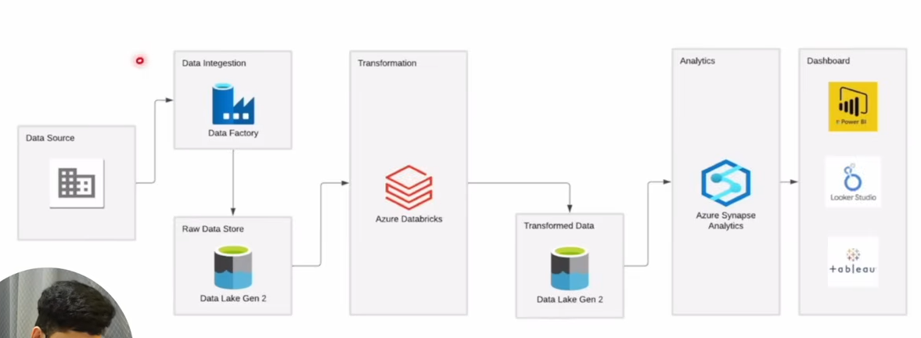

Azure data factory to extract the data
Load data to data lake storage (store structured and un structured data )
Azure databricks transformation
Azure synapse analytics – to run analytics query (sql queries)

Synapse analytics can do all that is done in the solution , different services are chosen for learning aspect

Datalake is similar to azure storage with hierarchial structure

Databricks
Configure compute
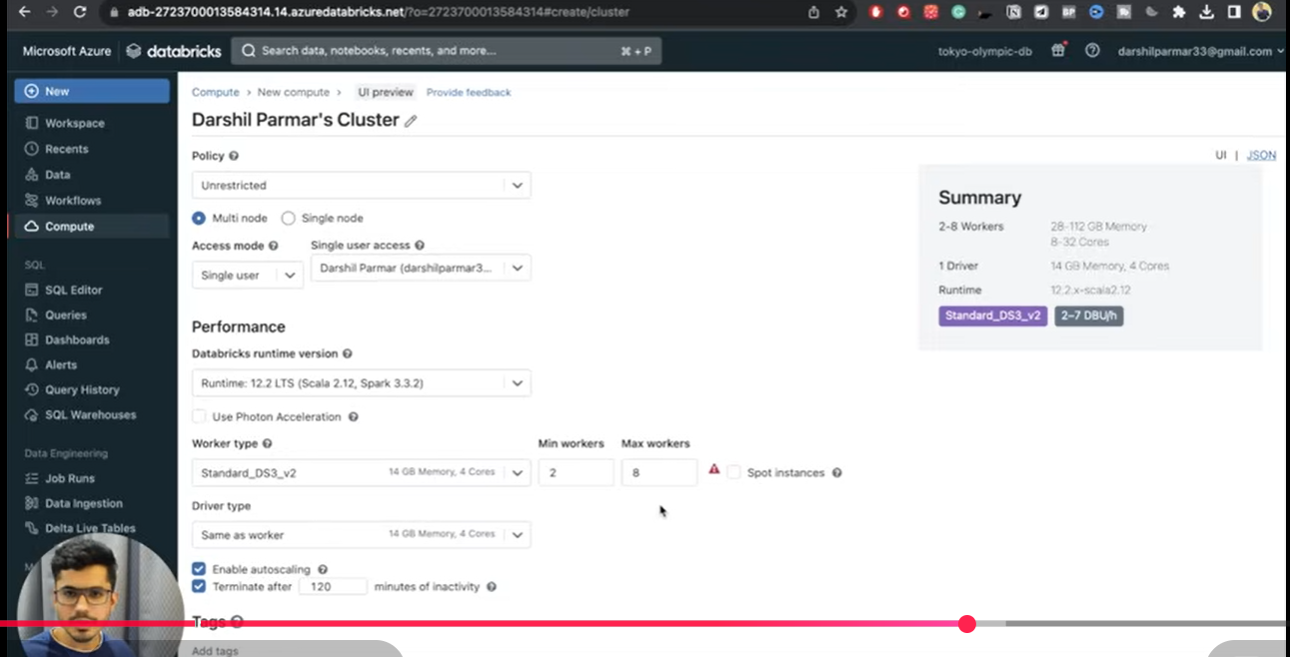
It is built on Apache spark
Create Notebook

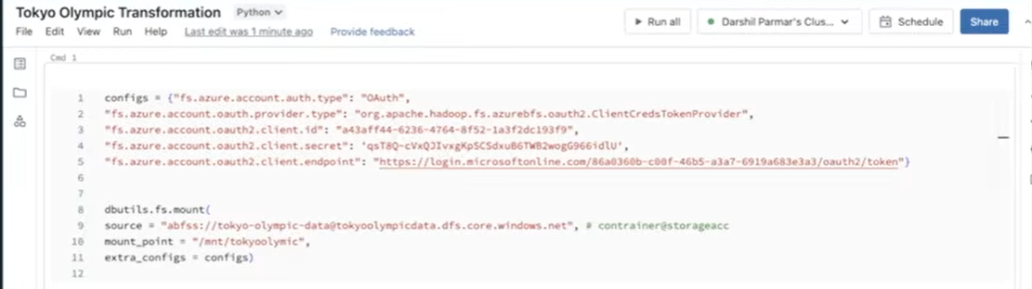
Azure Data Bricks

https://www.youtube.com/watch?v=-M2a8Sfe8_I

